GCS182 – Principles of computing and Programming

Project

Contents
1. Goal 3
2. Learning Outcomes 3
3. Program Requirements 3
3.1 Part A 4
3.2 Part B 4
4. Submission 5
5. Grading 5
6. Deadlines 5
7. Appendix: Project Code Grading Rubrics 6

Goal

For this project, you will write a Python solution to manage a library module of python functions that you will have to write that manipulate strings and lists.

Learning Outcomes
- CLO2: Developing algorithms to solve problems incorporating the concept of data abstraction in a computer program. [PLO: b]
- CLO3: Apply fundamental programming concepts, such as variables, loops, conditionals, functions, and arrays, in programming assignments. [PLO: f]
- CLO5: Working in groups to construct working programs for real-world problems. [PLO: e]

Specifications

1. The library module will contain three constants and eight function definitions.
a) It will include the following constants:
ASCII_LOWERCASE = "abcdefghijklmnopqrstuvwxyz"
ASCII_UPPERCASE = "ABCDEFGHIJKLMNOPQRSTUVWXYZ"
DECIMAL_DIGITS = "0123456789"
b) It will include the following functions:
- is_alpha( str ) returns bool
- is_digit( str) returns bool
- to_lower( str ) returns str
- to_upper( str ) returns str
- find_chr( str, str ) returns int
- find_str( str, str ) returns int
- replace_chr( str, str, str ) returns str
- replace_str( str, str, str ) returns str
The notation above gives the name of each function, the number and type of its argument(s), and the type of its return value.
c) The function names will be spelled exactly as shown (for example, is_digit).
d) Function is_alpha has one parameter (a string). It returns True if all of the characters in the string are upper case or lower case ASCII letters (it returns False otherwise).
e) Function is_digit has one parameter (a string). It returns True if all of the characters in the string are ASCII decimal digits (it returns False otherwise).
f) Function to_lower has one parameter (a string). It returns the string which is a copy of the parameter, but where all of the upper case ASCII letters have been converted to lower case ASCII letters.

g) Function to_upper has one parameter (a string). It returns the string which is a copy of the parameter, but where all of the lower case ASCII letters have been converted to upper case ASCII letters.
h) Function find_chr has two parameters (both strings), where the second parameter must be of length 1. It returns the lowest index where the second parameter is found within the first parameter (it returns -1 if the second parameter is not of length 1 or is not found within the first parameter).
i) Function find_str has two parameters (both strings). It returns the lowest index where the second parameter is found within the first parameter (it returns -1 if the second parameter is not found within the first parameter).
j) Function replace_chr has three parameters (all strings), where the second and third parameters must be of length 1. It returns the string which is a copy of the first parameter, but where all occurrences of the second parameter have been replaced by the third parameter (it returns the empty string if the second or third parameter are not of length 1).
k) Function replace_str has three parameters (all strings). It returns the string which is a copy of the first parameter, but where all occurrences of the second parameter have been replaced by the third parameter. If there are no occurrences of the second parameter in the first, it returns a copy of the first parameter. If the second parameter is the empty string, it returns the string which is a copy of the first parameter, but with the third parameter inserted before the first character, between each character, and after the last character.
l) The library module will NOT use any of the string methods listed in Section 4.7.1 of the Python Standard Library:
http://docs.python.org/3.3/library/stdtypes.html#string-methods
m) The library module will NOT contain any import statements.
n) The library module will NOT perform any input or output operations. For example, it will not call function input or function print.

2. The program to test your library module will demonstrate that each of the three constants and eight functions is implemented correctly.
a) It will contain one of the following import statements:
import proj03library
from proj03library import *
b) It may contain additional import statements.
c) It may use any of the string methods listed in Section 4.7.1 of the Python Standard Library. For example, it may use the string method lower as a means of determining whether or not the value returned from function to_lower is correct.
d) For each test case, the program will display the appropriate information so that someone reading the output can understand the purpose of the test and judge if the result is correct.
e) you need to use input and output files to test your functions.
f) your system should be robust enough (use try except and while loop validations when needed)

Suggested Procedure
- Solve the problem using pencil and paper first. You cannot write a program until you have figured out how to solve the problem. This first step is best done collaboratively with your teammates. However, once the discussion turns to Python specifics and the subsequent writing of Python statements, you must work on your own for the part assigned to you in the group discussion.
- Write a simple version of the library module and of the program. The library module should contain one function definition (perhaps function is_digit) and the program should contain your test cases to thoroughly test that function.
- Run the program and track down any errors.
- Cycle through the steps to incrementally develop your program:
  - Edit your library module and program to add new capabilities.
  - Run the program and fix any errors.

Submission
- You will submit in Blackboard, before the due date and time, the following:
  - A complete Report (including an introduction, a methodology explaining your work and how you solved the problems, screenshots of the codes and results, team work management, timeline, and explanation of the individual tasks for each team member, a conclusion reflecting on the whole project.
  - The python scripts with the data files.

- Late submissions will be subject to the late penalty described in the course outline. No exceptions will be made, including for technical and/or connectivity issues. Do not wait until the last day to submit.
- Only files uploaded into Blackboard will be graded. Submissions that contain incorrect, corrupt, or missing files will receive a grade of zero. Corrections to submissions will not be accepted after the due date and time, for any reason.

Grading
The grading of this project will be rubric-based, and the total grade will be divided into 3 parts:
- Project Code Grading Rubrics
- Report grading
- Presentation
Minimal criteria
In order to be graded, your program must meet the following minimum criteria: The program must be implemented in python, and it must compile and execute.

Deadlines
- Project part A: (4 first functions with a program test): 6th of May 2023
- Complete report and code: 20th of May 2023
- Presentation: 21st and 23rd of May 2023

Appendix: Project Code Grading Rubrics
- Coding standards Rubric
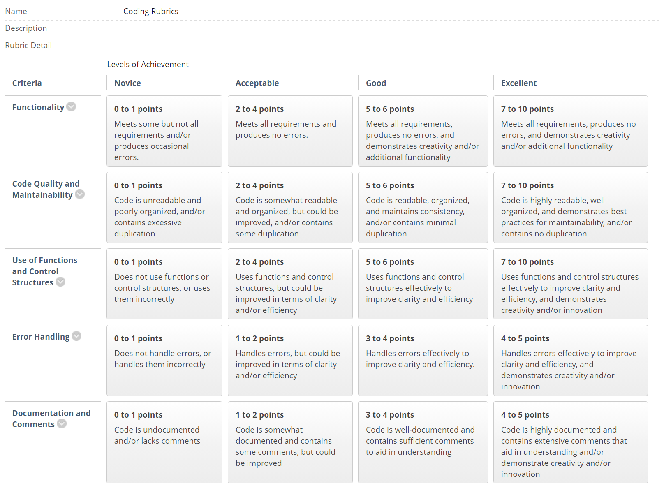
- Report Rubric
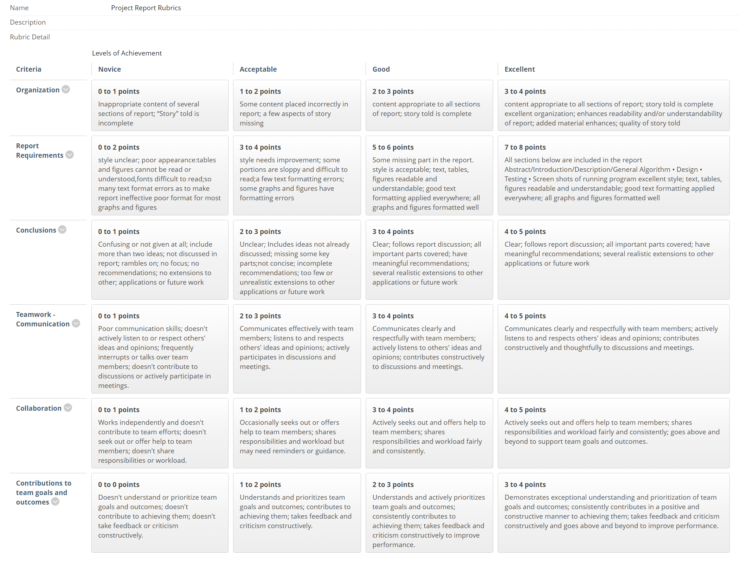

- Presentation Rubric

